**New User (Register Page and Flow):**

Usually after Guest placed their Orders successfully they will be shown link from where they can Create Account/Login



Register Page can be also navigated from Login (Need an Account? Register). Once they click on Create Account, users will be navigated to register page.



Register Page - <http://localhost:4200/register>

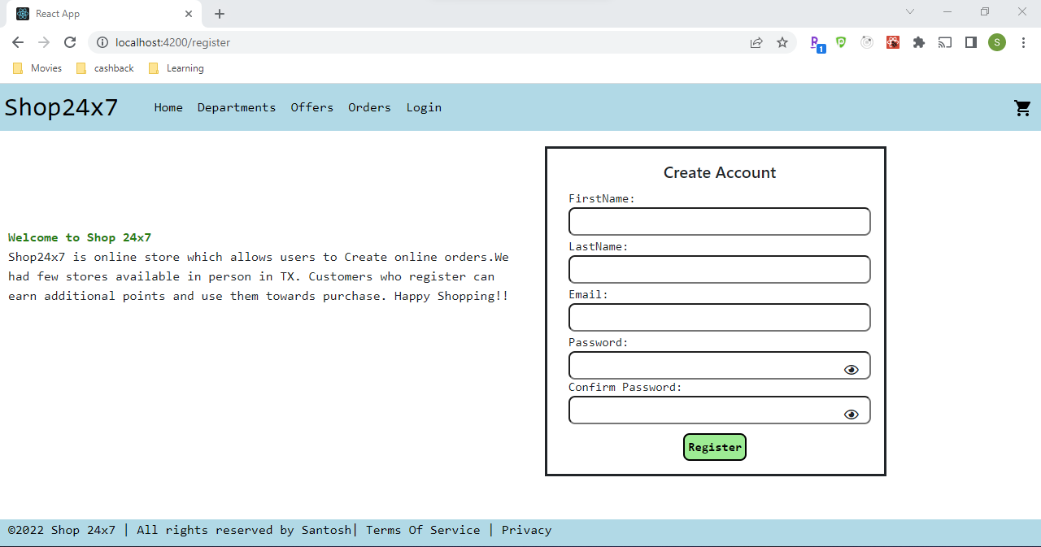

User will be shown error messages in below scenarios

1. When user input fields are empty,
2. password length <8
3. password and confirm password didn’t match
4. An information message in case if user already had account and still trying to create an account.

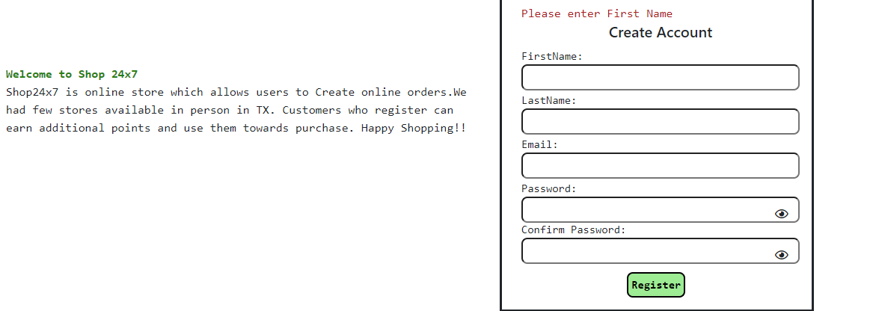

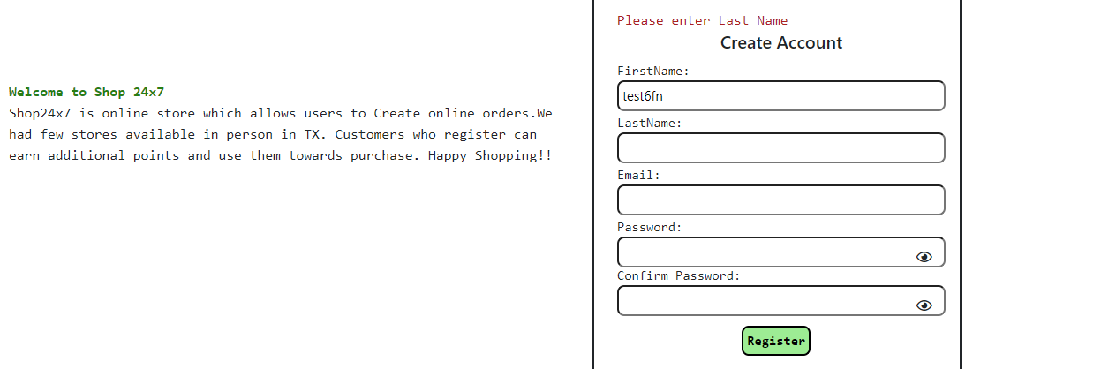

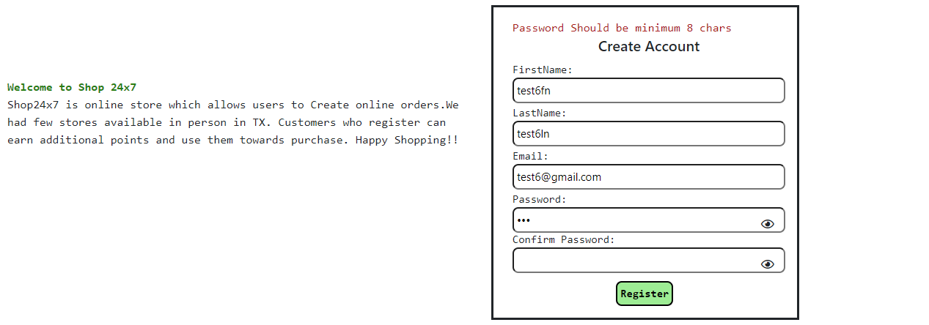

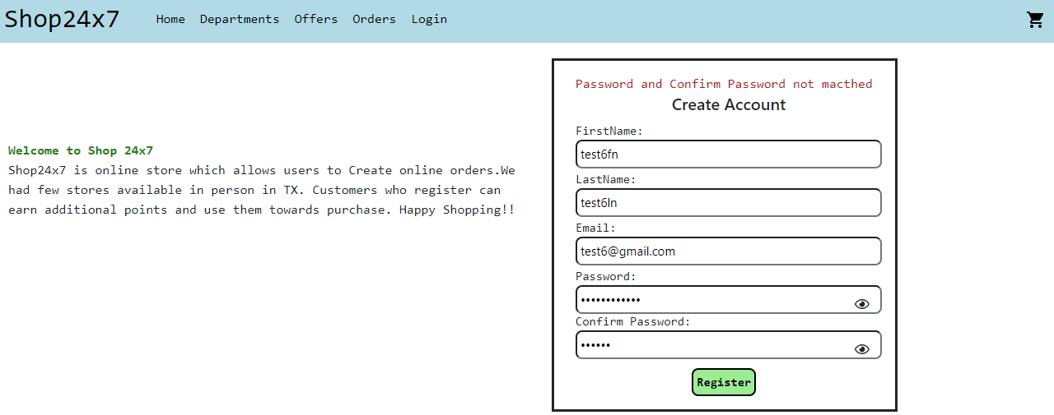

User can click on show Password (eye) symbol to see the password and confirm password entered.

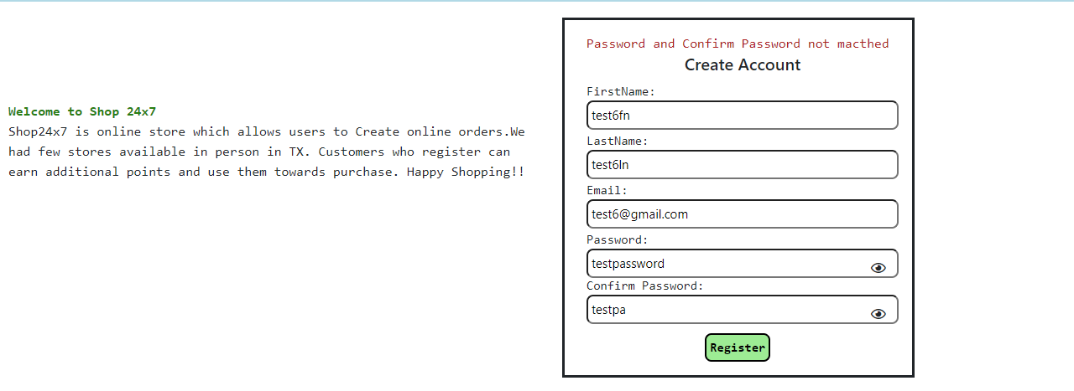

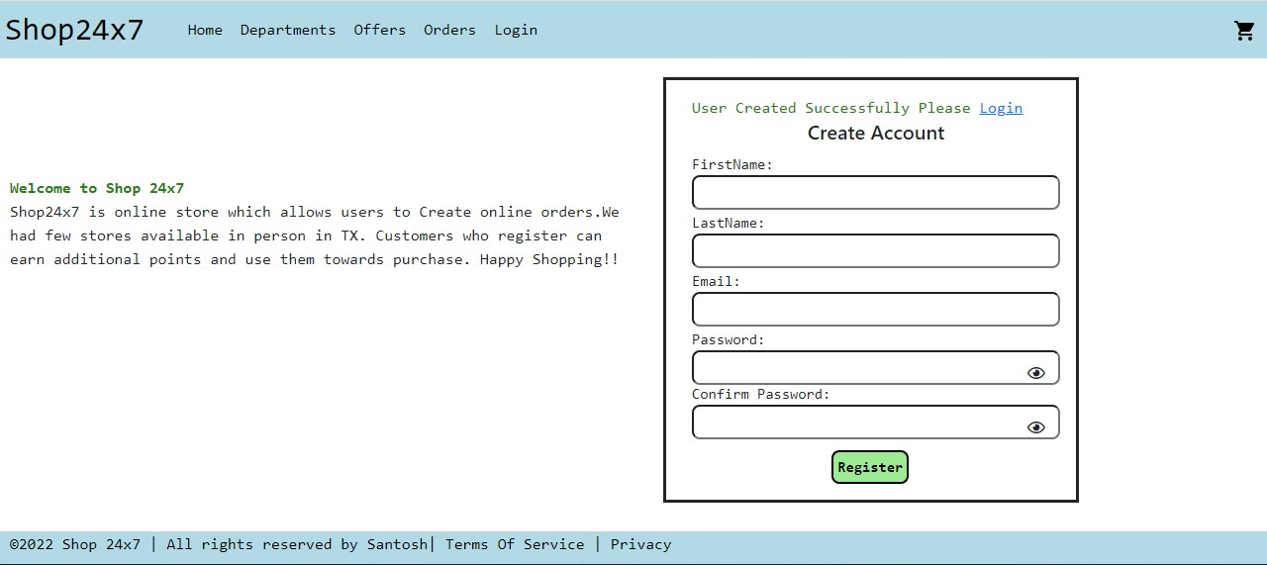

Once the user creates account and try to create account with same email, message will be shown to user that account already exists.

